Vintana Wine and Dine
Escondido, CA

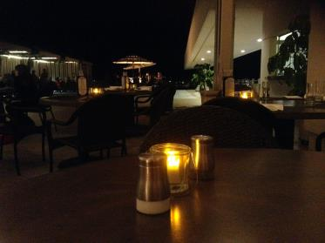

This restaurant is located above the Lexus dealership in Escondido,CA. We are not kidding. This is a beautiful restaurant sitting on the rooftop of a car dealership in Escondido, CA. While you are waiting for your dinner table you can either get a drink in the bar or shop for a new car!

The owner of the dealership,Judy Jones-Cone, originally imagined the space to be place for Lexus owners to grab a bite while waiting for their car. However, it has become much more. Cone partnered with Cohn Restaurant Group and chef,Deborah Scott, to create a wonderful restaurant. Cohn Restaurant Group has about a dozen restaurants in the San Diego area.

The name is inspired by the Spanish word Ventana meaning window and Vin, for its focus on wine. The restaurant definitely has windows. The restaurant has 17 foot tall windows that afford diners a great view of the city.

We recently went there for drinks. The patio alone is 10,000 square feet. They have a covered patio with heaters and fire pits. Additionally they have a huge, uncovered space that would be great for events. It has a fire feature in the middle, individual dining cabanas on one side and city views on the other.

The wine list is varied. We were impressed that you could get a bottle of wine in the low 20's or spend $100. They also have a wine shop where you pick up a bottle of wine and bring it to your table for no corkage. If you want to buy the wine to take home, you get 2 for the price as it appears on the wine list. (For example, we saw an Angeline Pinot and the price was $28 if you want to drink it in the restaurant or $14 if you want to take it home with you.)

Next time we will have to try the food! The dining room wraps around the outside of the dealership and has great city views. Chef Deborah has a great reputation for making interesting dishes.

