Urban Wine Trail

Downtown Santa Barbara used to have just a handful of tasting rooms. Not anymore! There are about 20 tasting rooms located in the downtown area with more than a half dozen within walking distance of the train depot. Most are open daily and many are dog-friendly.

If you are looking for a nice day trip, consider taking the train. Amtrak Pacific Surfliner has a number of trains that run daily from San Diego to Santa Barbara (with multiple stops in between). The Santa Barbara depot is within walking distance of the beach and wharf, bike rentals, many places to eat and drink and buses to take you to the Zoo.

We boarded the Amtrak in Burbank and met friends who boarded the train in Simi Valley. Amtrak does not have priority over the freight trains so sometimes they have to sit and wait. If your schedule can handle that, then it's a great way to go. The trains are comfortable with wi-fi, snack bar, complete with cocktails.

When we got to Santa Barbara we walked down the street to Metropulos Deli. It is a very popular spot with a deli, tiny market, wine shop and restaurant. We got our lunch to go, (good thing because all of the tables were occupied) and headed to Santa Barbara Winery. Santa Barbara Winery was founded in 1962, the oldest winery in the county and I believe, the first downtown tasting room. The tasting room is always busy and they have shaded patio with tables for picnics.

Across the street from SB Winery is Pali. They opened the SB tasting room in 2012. Pali is one of our favorite wineries. Established in 2005, they produce a variety of wines but they specialize in Pinot Noir and Chardonnay from vineyards and AVA's that specialize in those grapes. They make some awesome Pinots. We especially liked the Riviera Pinot! Aaron Walker is the winemaker. The tasting room is located in a new building that is a combination live/work space. Retail on the first and second floor and living lofts on the third. Very cool concept!

One of our friends is more into beer so we spent some time at Union Ale. It is a fun place to go. It is a craft brew place that offers their own as well as other craft beers. It's very casual. You order at the bar and they bring it to your table.
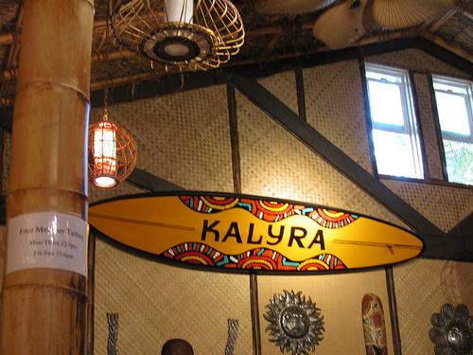

Kalyra, a popular tasting room with the locals, is a combination tiki room/surf shack. Very cute! We found several wines that we enjoyed. The Australian-born winemaker applies his years of experience in California and Australia, blending his wines with grapes from Santa Barbara County, California, Australia, Portugal, France, Spain and Italy.
Cottonwood Canyon is another newcomer to downtown. The small, intimate tasting room features a variety of interesting wines. Winemaker, Norman Beko, specializes in Pinot Noir, Chardonnay and Syrah. If you get the chance, visit their winery, near Santa Maria. Norman leads a very interesting and educational tour of his vineyard and caves!

As we headed back to the train we passed Oreanna Winery. The place was buzzing with live music and a good sized crowd. We didn't have time to stop but it will definitely be on our to-do list for our next adventure on the Urban Wine Trail.

