Tinto- Palm Springs
1800 E. Palm Canyon Dr.
Palm Springs, Ca. 92264

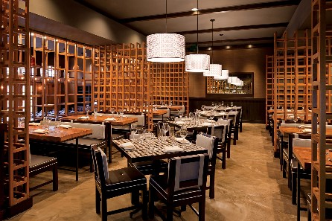

We went to this tapas restaurant in the new Sagauro Hotel. The restaurant is patterned after the restaurant of the same name in the Arizona Sagauro and the original in Philadelphia. "Tinto is a colloquial expression used to describe the red wine served in typical pintxos bars throughout Northern Spain. It is the ultimate expression of what a Basque wine bar should be. It draws inspiration from the rich cultural and culinary traditions of the Basque country. It inspires,tantalizes and satisfies all who enter with the extraordiary cuisine created by chef, Jose Garces. "

We arrived with another couple around 5:30 on Saturday evening and we were told that the place was booked for the evening. Luckily, there was room in the bar at one of their high tables. The physical menu is unique. It is on a piece of paper and folded origami-like.

We had a variety of different small plates throughout our leisurely two and a half hour meal. We started with a charcuterie "mixto". It was a platter with four different types of cured meats. Then we had a cheese "mixto" platter with about 4 different cheeses. We favored the meat platter over the cheese platter but both were good. Next, each of us ordered a small plate and they came out one at a time. Each one was delicious with inspiring ingredients and tastes.

Lamb wrapped in bacon and served with a eggplant sherry jus- delicious!

Duck with Serrano Ham

Short Rib sandwich- braised to perfect tenderness and served with a celery root aioli

Scallops with shaved apple and a cider Demi-glacé

They have a full bar and a wine list featuring Spanish wines. This time we opted to bring our own wine. Next time we will have to explore the Spanish wines. They also offer a Chef's tasting for $55 per person (or $85 for tasting with wine pairings). We're not sure what is included but we were told that it is a multi-course meal including a dessert course.

It was a lot of fun trying this unique restaurant. The service was good. The food was excellent. The interior is warm and comfortable. It is a dining experience. Definitely not an inexpensive dining experience. Our total came to about $40 per person for the food that we ordered (not including drinks, tax or tip). Don't go if you are on a budget or you have a time constraint! But if you are looking for a unique, leisurely way to spend an evening with friends, this is the spot!

