SMALL BITE OF THE MONTH – SEPTEMBER 2010

Roasted Shrimp with Pineapple Salsa
(Serves 6)

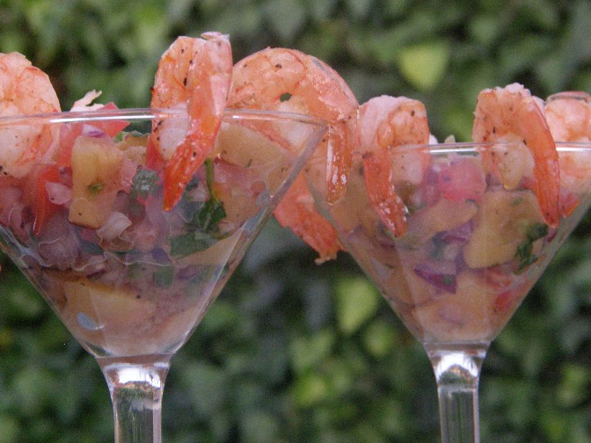
Ingredients

--salsa--
1/2 pineapple (cut into 1/2-inch-thick slices)
3/4 c. chopped red onion
1/4 c. chopped fresh cilantro
2 T. chopped seeded jalapeño chili
2 T. olive oil
2 T. fresh lime juice
Kosher salt and fresh ground pepper (to taste)

--roasted shrimp--
2 lbs. (12 – 15 count) shrimp, peeled and deveined
Olive oil
Kosher salt and fresh ground pepper
Fresh lime juice

Preparation

Sprinkle 12 pineapple slices with salt and pepper. Grill* pineapple until just tender, about 4 minutes per side. Transfer to work surface; cut pineapple into 1/2-inch pieces. Place in bowl; mix in onion, cilantro, chili, 2 tablespoons oil and 2 tablespoons lime juice. Season salsa with salt and pepper. Chill in refrigerator for at least 1 hour or overnight to blend tastes.

Preheat oven to 400 degrees.

Peel and de-vein the shrimp, leaving the tails on. Place them on a cookie sheet with olive oil, salt and pepper and drizzle with lime juice. Roast for 8 to 10 minutes, just until pink and firm and cooked through. Set aside to cool.

Fill martini glasses with salsa. Hang 4 - 6 shrimps on rim of each glass. Enjoy!

*Can be grilled on indoor or outdoor BBQ or Panini grill. Whatever works for you!

