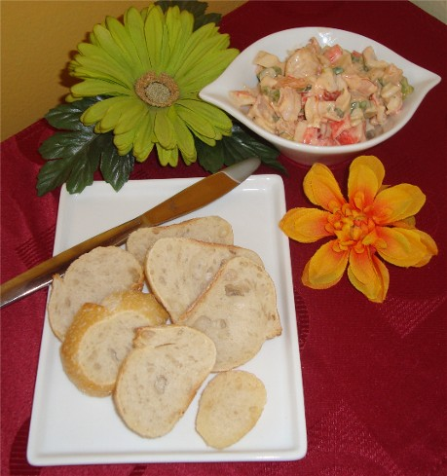
Crostini with Spiced Crab and Shrimp Salad
1/2 cup bottled clam juice
10 ounces medium uncooked shrimp, peeled, deveined
2 cups thinly sliced green onions
2/3 cup mayonnaise
4 teaspoons fresh lemon juice
2 garlic cloves, finely chopped
1 teaspoon Hungarian sweet paprika
1/2 teaspoon cayenne pepper
8 ounces flaked crabmeat (about 2 cups lightly packed)
1/3 cup (about) olive oil
40 1/4-inch-thick diagonal slices sourdough baguette

Bring clam juice to simmer in large skillet over medium heat. Add shrimp; cover and simmer until opaque, turning once, about 2 minutes. Using slotted spoon, transfer shrimp to cutting board; coarsely chop shrimp. Place shrimp in small bowl. Boil cooking liquid until reduced to 2 tablespoons, about 2 minutes. Cool.
Mix onions and next 5 ingredients in large bowl to blend. Stir in shrimp, cooking liquid and crabmeat. Season with salt and pepper. Cover and chill for at least a few hours. Preheat oven to 375°F. Lightly brush oil over both sides of each bread slice. Arrange bread on baking sheet in single layer. Bake until bread is crisp and golden, about 4 minutes per side. Cool. (Seafood salad can be made up to a day in advance. Keep seafood salad chilled.)
Transfer seafood salad to a serving bowl and arrange crostinis on a tray. Garnish salad with lemon wedges , if desired.

