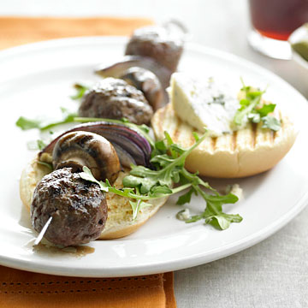

Blue Cheese Burger Kabobs

ingredients
2 cloves garlic, minced
2 Tbsp. dry red wine or beef broth
1 Tbsp. Worcestershire sauce
1 cup coarsely chopped parsley (1/2 of a small bunch)
1 lb. ground sirloin or 85 percent lean ground beef
2 oz. coarsely crumbled blue cheese
1 small red onion, cut in wedges
1 6- to 8-oz. pkg. large cremini mushrooms
2 Tbsp. olive oil
4 slider hamburger buns, split
2 cups arugula
Blue cheese wedges (optional)

directions
1. In a large bowl, combine garlic, wine, Worcestershire, parsley, 1/4 tsp. salt, and 1/8 tsp. pepper. Add meat; mix well. Gently stir in crumbled blue cheese until just combined. Form meat into 12 meatballs. Cover and chill at least 1 hour.
2. On four 12-inch presoaked skewers, thread meatballs, red onion and mushrooms, leaving a quarter inch between pieces. Brush onion and mushrooms lightly with olive oil and sprinkle lightly with salt and pepper.
3. For charcoal grill, place kabobs on a greased grill rack directly over medium coals. Grill 14 to 16 minutes or until meat is no longer pink (160 degrees F), carefully turning once halfway through grilling. Add hamburger buns and grill the last 1 to 2 minutes until toasted. (For a gas grill, preheat grill; reduce heat to medium. Cover and grill as above).
4. Serve kabobs with buns, arugula, and blue cheese wedges. Makes 4 servings.

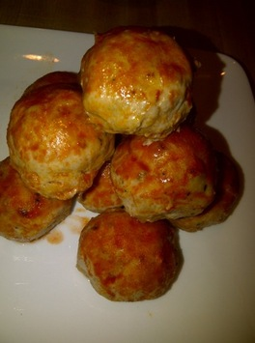

Buffalo Chicken Meatballs

ingredients
1 lb. ground chicken (preferably ground chicken breast)
1 teaspoon granulated garlic
1 teaspoon red pepper flakes (a little more if you like it spicy like we do)
Salt and fresh ground pepper to taste
4 Laughing Cow Blue Cheese Wedges (or real blue cheese), cut into thirds
1/2-3/4 cup hot sauce (preferably Crystal, if you know what’s good for ya!)

directions
Preheat oven to 350 degrees. Spray an 8” x 8” glass casserole dish lightly with some non-stick spray. In a large bowl, combine ground chicken and all the spices. Mix well, using your hands.

Take a rounded teaspoon of the chicken mixture and flatten it a bit in the palm of your hand. Place one of the Laughing Cow thirds in the center, then top with another rounded teaspoon of the chicken mixture. Roll around between the palms of your hands lightly, forming a ball*. Be sure to fully ensconce the blue cheese inside. Place in casserole dish. Repeat, until you have 12 balls (you may end up with a couple more or less).

Bake for 20-25 minutes, until cooked all the way through. Remove from oven, and pour hot sauce over the top. Return to oven for 5 minutes to heat hot sauce.

